

MACHINE LEARNING ASSIGNMENT

SUBMITTED BY:

GURKIRAT SINGH

03213202717

CSE-1
Github link for code :

https://github.com/gurkiratsingh-1/ML_Assignment_Gurkirat

Question 1: Create a program that asks the user to enter their name and their age. Print out a message addressed to them that tells them the year that they will turn 100 years old.

Extras:

- Add on to the previous program by asking the user for another number and printing out that many copies of the previous message.

- Print out that many copies of the previous message on separate lines. (Hint: the string "\n is the same as pressing the ENTER button)

Pseudocode

- Take number and age as input

- Take a variable of current year

- Add value of current year with difference of 100 and current age

Program Screenshot
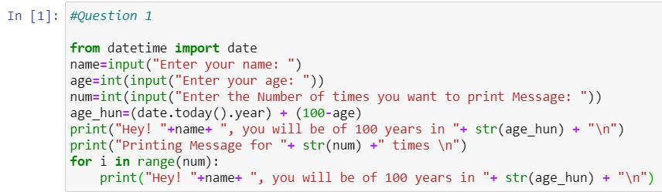

Output:

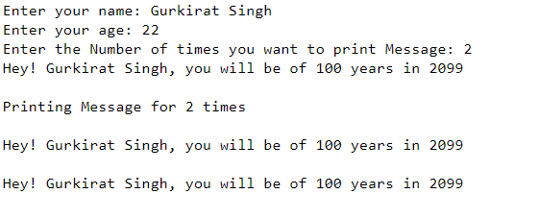

Question 2 : Take a list, say for example this one:

a = [1, 1, 2, 3, 5, 8, 13, 21, 34, 55, 89] and write a program that prints out all the elements of the list that are less than 5.

Extras:

- Instead of printing the elements one by one, make a new list that has all the elements less than 5 from this list in it and print out this new list.

- Write this in one line of Python.

- Ask the user for a number and return a list that contains only elements from the original list a that are smaller than that number given by the user.

Pseudocode

- Normal Code

- Run a for loop

  - Compare each element with 5

  - If less than 5, print

  - Else iterate to next element

- Creating a new list

  - In an empty list run for loop on original list

  - If element is less than 5, add it to list

  - Else iterate to next element

Program Screenshot
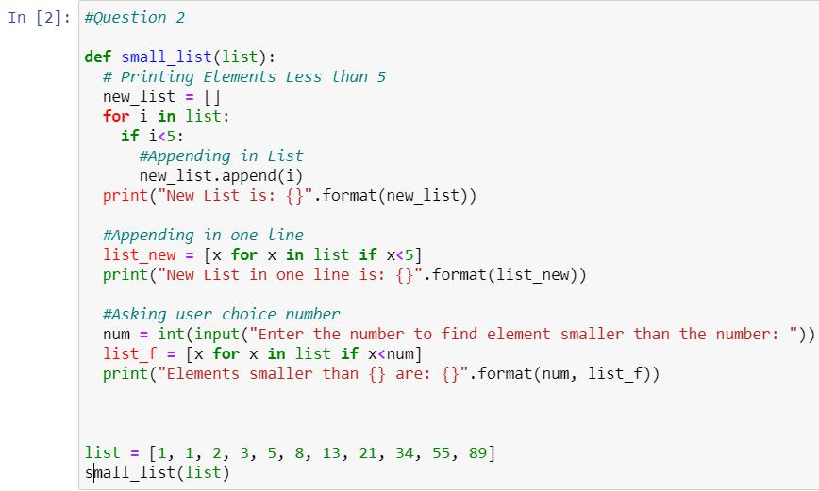
Output
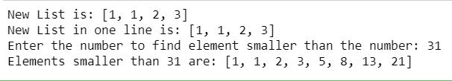

Question 3: Write a program that asks the user how many Fibonacci numbers to generate and then generates them. Take this opportunity to think about how you can use functions. Make sure to ask the user to enter the number of numbers in the sequence to generate. (Hint: The Fibonacci sequence is a sequence of numbers where the next number in the sequence is the sum of the previous two numbers in the sequence. The sequence looks like this: 1, 1, 2, 3, 5, 8, 13, ...)

Pseudocode

- Take number as input

- Initialize two variables for first and second term

- Print Second term

- Run a for loop from 1 to number

- Take sum of first and second number

- Set first number = second

- Set second number = sum

- Print sum
Program Screenshot
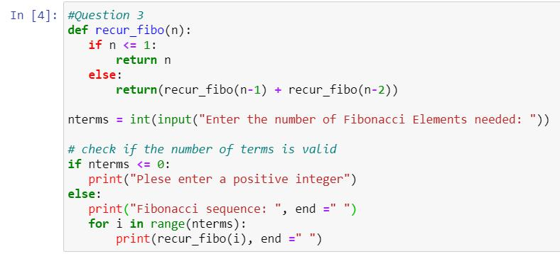

Output
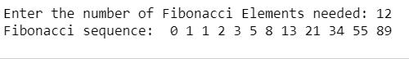

Question 4 : Write a program (function!) that takes a list and returns a new list that contains all the elements of the first list minus all the duplicates.

Extras:

- Write two different functions to do this - one using a loop and constructing a list, and another using sets.

Pseudocode

- Using Loops

- Create a new list

- Run a for loop for all elements

- Add element to new list if it isn’t present o Else don’t add element and iterate to next

- Using sets

- Typecast the list to set

Program Screenshot
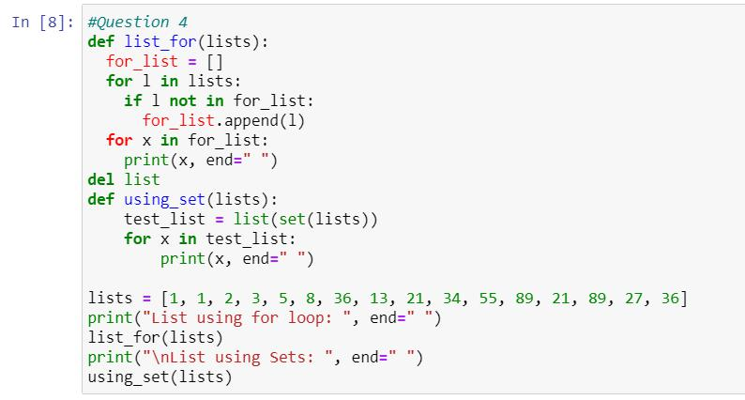

Output
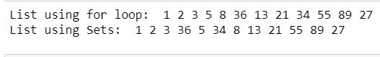

Question 5 : Ask the user for a number and determine whether the number is prime or not. (For those who have forgotten, a prime number is a number that has no divisors.). Use functions

Pseudocode

- Input a number

- Set flag = 1

- Run a loop from 2 to square root of number

- If number is divisible in loop, set flag = 0 and exit the loop

- Else continue

- If flag is 1, number is prime

- Else number is not prime

Program Screenshot
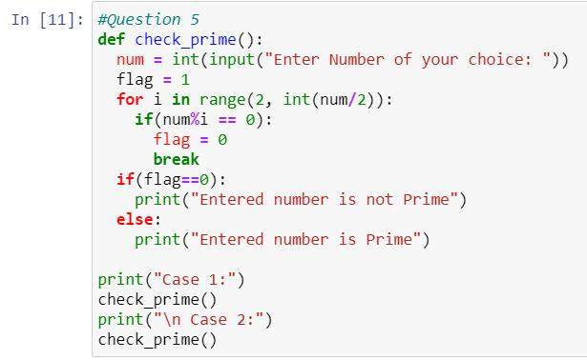

Output
